**Year 2** Friday 13th January 2022

**Value of the Month: Hope**

**This Weekend Please Ask Me (From Term 3 Week 2)**

* What does divide mean? (Share equally)
* Can I draw the symbol we use for dividing? (÷)
* What did you draw to help you divide? (Bar model)  
    
  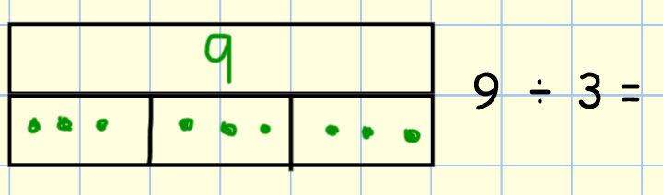
* What is the top box in the bar model? (whole) What are the bottom boxes? (parts)
* Can I show you how I work out these calculations: 8 ÷ 2 =, 12 ÷ 4 =, 18 ÷ 3 =, 24 ÷ 3 = ?
* What is an explanation text? (Non-fiction text that explains why things are as they are)
* Why might you read an explanation text? (To learn information e.g the non-fiction books that we have been looking at on animals this week)
* Can I tell you what a subordinating conjunction is? (A special words that joins two ideas together – we are using it to explain our facts: as, because, in order to: polar bears are white so that they are camouflaged against the snow.)
* How has a penguin adapted to life in Antarctica?
* Can I tell you what animal I designed for the Polar regions and what special features they had to help them survive in that habitat? E.g. blubber to keep warm, webbed feet to swim,
* Can I tell you the story of why Simon-Peter decides to follow Jesus? (Simon-Peter was impressed with what Jesus said and did, healing people and then Jesus told Simon where to put his nets to fill them with fish)

**Homework for next week – Term 3 Week 3**

**Spelling**

**BLUE** **GREEN** **YELLOW** **PURPLE**

|  |  |  |  |
| --- | --- | --- | --- |
| catch | catch | catch | catch |
| they | they | fur | survive |
| fur | fur | Antartica | habitat |
| because | feathers | habitat | so that |
| so that | so that | so that | harshest |
| in order to | because | conditions | species |
|  | in order to | species | endangered |

Can you use a dictionary/ Google to research any words you do not know the meaning of yet.

**Making Spellings Fun!** We do appreciate that spellings are not the most fun thing to learn but as we say to the children ‘it won’t happen magically’ so we do need to find a way to practice them. In the front of the books there are some suggests of different ways to practice but there really are no rules! Use a paintbrush and water and paint them on the patio. Use chalk, if you have an area to do so? Use a computer or tablet to create them in word art, write a song to help you spell them. Today we drew a massive penguin and wrote penguin as many times as we could inside it and it was holding a pen to remind us that it starts with pen! We don’t mind how creative you get in your books!

**Reading**

Please continue to read for 5-10 minutes a day with your child. This week when you are reading with your child why not look at punctuation when you are reading? We are working with children to make sure they stop at the full stops, take a breath when there is a comma and to use expression when someone is speaking.

**English Homework** – As you know this week we are focusing on polar habitats. Which is your favourite animal in that habitat? Use the sheet attached and can you find out all about your animal? What features does it have to help it survive in the cold conditions? Look at its feet, fur/feathers, legs/wings, beaks/mouths etc… Can you complete this and if possible bring it in on Monday as it will help you in our writing activity this week.

Show and Tell: Animals and their Habitats. This term we would like the children to find out about their favourite animals habitat. What does it provide for the animal e.g. Does it provide shelter to keep them safe?, Water for them to drink? A specific type of food? Warmth? They can present this information anyway they like:

Show and Tell: Animals and their Habitats: 2RC: Morgan, Millie, Mason, Lucas and Joshua and 2VH: Mila, Lucas, Alice, Tabitha and Elizabeth.