Maths  Learning Focus: I can subtract.  - Using quantities and objects, I can subtract two single-digit numbers. (Extend to numbers beyond 10 if your child shows confidence and understanding.)  - I can draw a subtraction number story  - I can complete a cherry model to represent my number story  - I can write a number sentence to represent my number story (extension)  1. I will need ten small toys (eg cars, lego, peppa pig characters/play mobile/happy land people etc) I will not need all ten of my toys for each number problem. It will be helpful if I have my toys available for the live Maths sessions.  Here are some suggestions of number problems I could find the answers to:  - If I put 7 of my toys in a group, then take 3 of them away, how many will I have left? How can I show this in my cherry model? (Extension: Can I write a number sentence too?)  - If I put 10 of my toys in a group together, then take 4 of them away, how many will I have left?  2. I could draw a subtraction number story. I could draw a plate of 6 chocolate buttons and pretend to eat 3 of them. I could put a line or a cross through the ones I have ‘eaten’. How would I show this in a cherry model? (Extension to write a number sentence to represent number story if child shows understanding).  Repeat by changing the quantities each time.  You should now have your child’s log in details for Doodle Maths. The children really enjoy this activity, so if you haven’t yet logged on, please do. We have set the children a challenge to get them started. | Year Reception  Home Learning Week 4  Week Beginning: 25/01/21  smos9315@blake.oxon.sch.uk  soconnor@blake.oxon.sch.uk | English  Owl Babies  by Martin Waddell  Learning Focus:  - I can draw a picture of something I liked from the story.  - I can write a word or sentence independently, that can be read by myself and by other people using sounds I can hear in words.  Draw a picture of your favourite part of the story. Then you can add some writing to your picture.  - I can write the word ‘sat’ independently.  - I can write the sentence, ‘They sit and they wait’.  - I can write my own sentence about my picture.  - I could even try to re-write the story.  Link to online version on BookTrust website:  https://www.booktrust.org.uk/books-and-reading/have-some-fun/storybooks-and-games/owl-babies/  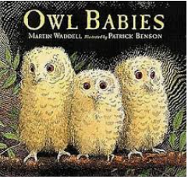
Topic – Our Wonderful World
Brilliant Birds

January 29th – 31st is National Big Garden Bird Watch
You can read more about this here: https://www.rspb.org.uk/get-involved/activities/birdwatch/

This fits in perfectly with our topic of Our Wonderful World. We are going to learn about different types of birds in Great Britain; we will discuss types we see in our gardens or out on walks.

Bird watch
Make some binoculars (if you made some for your bear hunt, you can use the same ones), or use some real ones if your grown-ups at home give you permission. Use these to look out of your window to look out for birds. We have added a Garden Bird Sighting Checklist for you to print off at home. Let us know if you would like to collect a hard copy and we will leave this with the school office

Bird food
You could make some bird food to put in your garden. Here is a link to a short video on how to make some.
https://www.youtube.com/watch?v=PPH2RmVnKu8&safe=true

Craft
You could engage in some craft activities linked to birds. We will put a larger version of the image below on Tapestry.
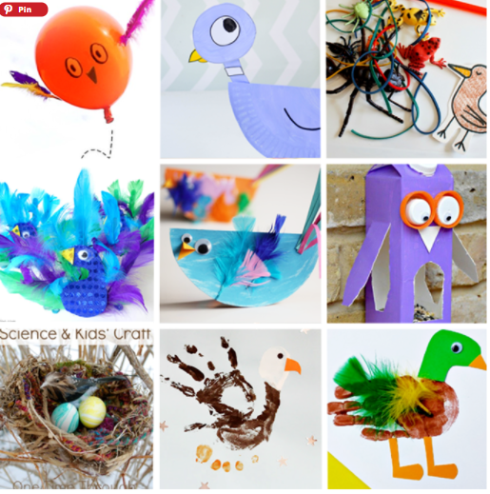

Here is a link to Activity village for other bird related craft ideas.
We look forward to seeing all your creations on Tapestry.

Phonics/ Spelling  On the Reception page of the Blake School website, you will find the Reception phonics sound order, which details the order we teach sounds. You will also find the sight words list and handwriting phrases.  Your child’s third target is to learn how to spell the set 3 sight words once they are confident with writing sets 1 and 2. They can begin to learn the fourth set if they are ready. (extend as necessary for your child)  This week some of us are learning the ‘qu’ digraph, and some of us are learning the ‘ur’ and ‘ow’ digraphs. Geraldine the giraffe is great fun to watch as a way to consolidate learning. Find the links below:  ‘qu’ https://www.youtube.com/watch?v=mYGGk0MH_xQ  ‘ur’  https://www.youtube.com/watch?v=0uVVJXbc870&safe=true  ‘ow’  https://www.youtube.com/watch?v=GJtvjxBYg7I&safe=true  Useful links:  Phonics Bloom: https://www.phonicsbloom.com/  Phonics Play: https://www.phonicsplay.co.uk/  Read Write Inc. Phonics lessons at home through the Ruth Miskin YouTube Channel: https://www.youtube.com/channel/UCo7fbLgY2oA_cFCIg9GdxtQ?safe=true |  | Reading  Try to make sure you are doing a little bit of reading every day. As well as hearing your child read, read a variety of books to them. Make use of YouTube and book trust as they have many recordings that your child can listen to online.  - Do I have any other books in my house written by Martin Waddell? If so, what do I like about his books? Do I have a favourite one? Who are the characters? What happens in the story?  Have a look on the Oxford Owl website. They have lots of free online books: https://www.oxfordowl.co.uk/  Take a look at Audible. They have lots of free audio books to listen to: https://stories.audible.com/start-listen  Please remember to let us know if you require more reading books. You can notify us by email or on Tapestry, and we will contact you to arrange.
P.E.

Jump Start Johnny you could have a go at one of the activities on YouTube by Jump Start Johnny, for instance, this one: https://www.youtube.com/watch?v=CD5Xa4Zt4Zc&safe=true

PE with Joe: You might want to have a go at Joe Wicks’ workouts that are streamed live at 9am on YouTube on a Monday, Wednesday and Friday and will last for 20 minutes: https://www.youtube.com/user/thebodycoach1?safe=true

