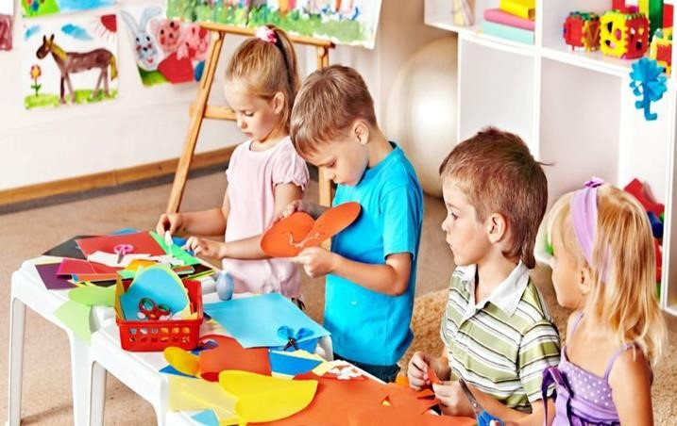
Holiday
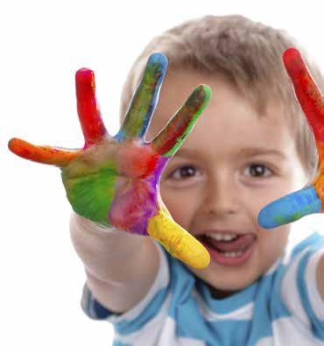
activity

pack

Reception

We appreciate that this is not a normal ‘Easter holiday’, and also that some families are dealing with illness and/or strange working patterns. We are keen to ensure that we limit the demands on families and that we provide enough for children to do without feeling under pressure. So, here are some activities to have a go at.
If you would like more ‘structure’ to the home learning, as last week, we have also uploaded a Home Learning grid of ideas for ‘Week 3’ to our year group page of the website.

We hope that you have been able to access Tapestry. We are currently uploading a few videos each week to teach phonics sounds and read storybooks. If you would like to upload photos of your learning at home (e.g. your child riding a bike, doing craft, reading, playing maths games, dancing etc.) then please do. We have really enjoyed seeing what some of your children have been up to at home.

Please also feel free to email the Reception teachers if you have any questions.
Mrs Moss – smos9315@blake.oxon.sch.uk
Mrs Rowlands – nrowlands@blake.oxon.sch.uk
Mrs O’Connor:- office3600@blake.oxon.sch.uk

Please note: most of these activities can be recreated by being copied on to a piece of paper, however, if you do not have the resources to enable your child to access this resource, please contact us via email.

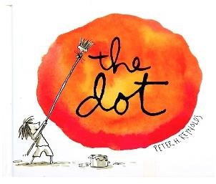
The dot
• Watch the story called The Dot, by Peter Reynolds. (Link to the story: https://www.youtube.com/watch?v=vKCsqbiCxE8 )
- Create a dot in a box (you can re-create this grid and these dots on a plain piece of paper – there is no need to print this out).
- Then use your imagination to turn the dot into something.
- Make sure the dot is still clear when your picture is finished.

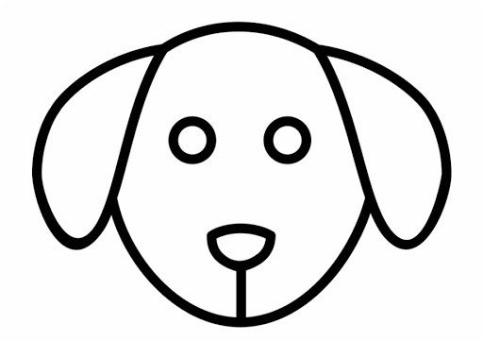

Which one do you think is your best picture and why?
The dot

- The dot has changed colour!
- Now what can it be used to create?

Which one do you think is your best picture and why?

The dot
- This time decide on what colour you would like the dot to be. It could be the same colour for each box or it could be a different colour each time.
- Now what can it be used to create?

Which one do you think is your best picture and why?

The dot
Create your own pieces of dot art. Be creative!
Some examples have been provided in the first box to help you.

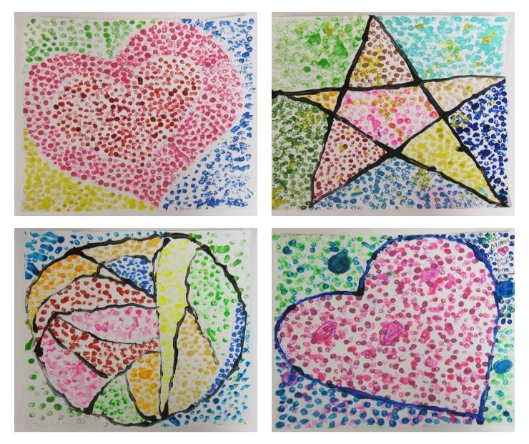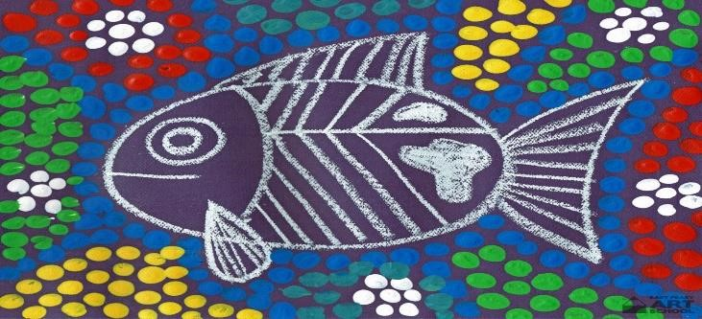

Learn British Sign Language
- Learn the alphabet.
- Learn to spell your name.

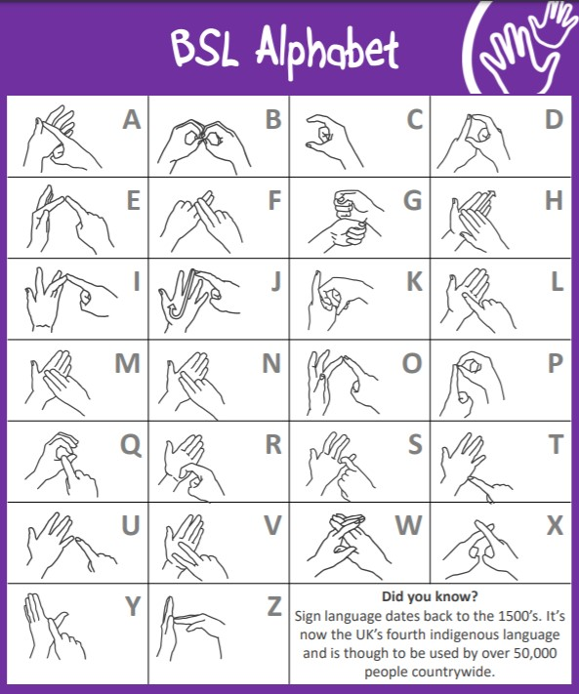

Learn British Sign Language

- Learn some simple sentences
- Try saying these in British Sign Language:

My name is …

My Mum’s / Dad’s name is … (you could just sign the first letter of their name)

My sister’s / brother’s name is … (you could just sign the first letter of their name)

• Using the sign language actions below, what else could you say?

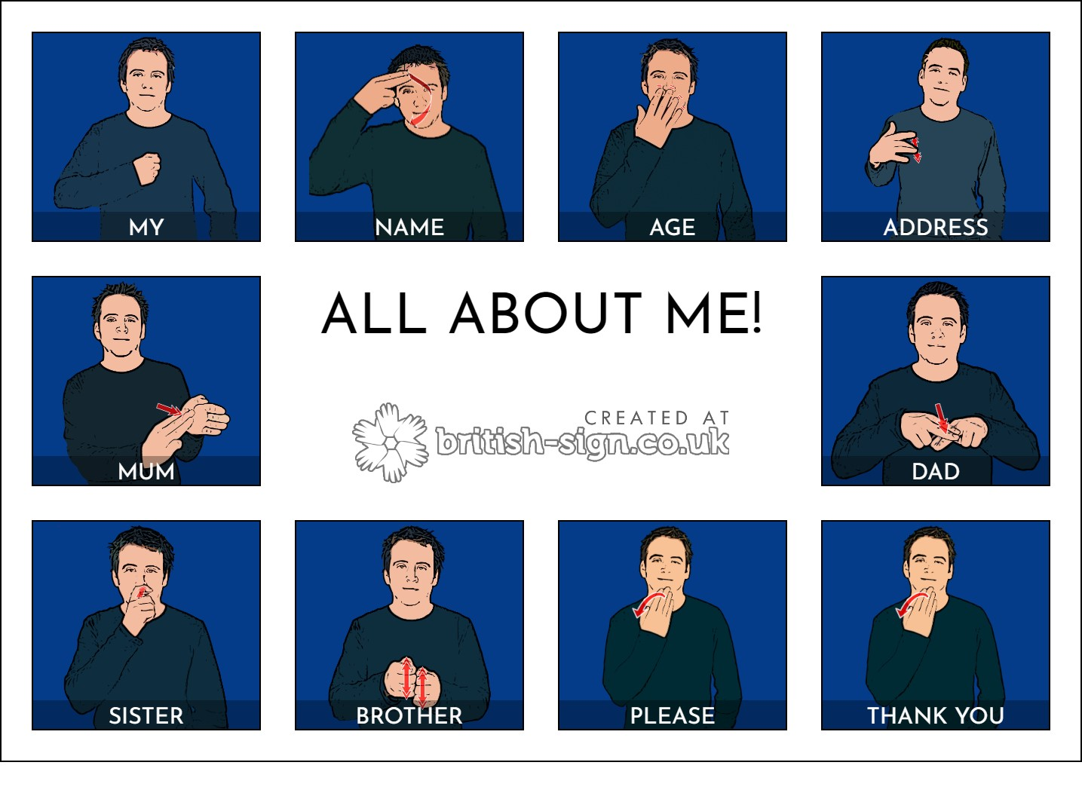

Hand Art
Draw around your hand and then…
- Using just three colours, decorate it as creatively as you can.
- Decorate it using 2D shapes.
- Turn it into an animal.
- Decorate it with things you can find in nature.
- Decorate it with pictures of your favourite things.

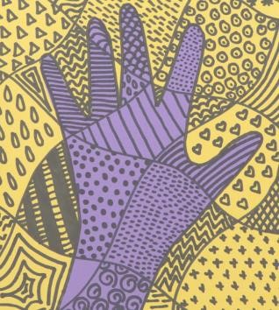

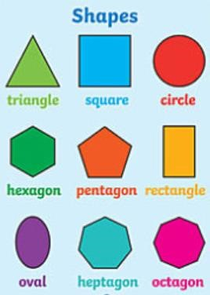

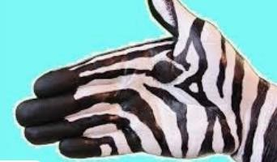

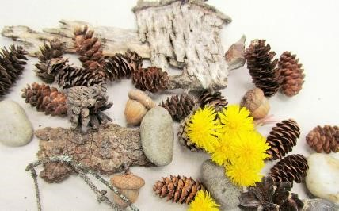

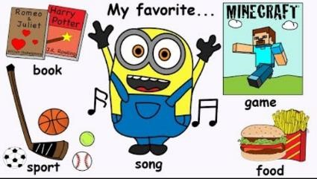

Word challenge
- Ask your parents/older siblings to copy the following categories onto paper then you can cut them up and put them into a pot.
- Choose a letter from the alphabet.
- Randomly choose a category card.
- Try to name five items, starting with the letter you chose which are in that category. Set a two minute timer.

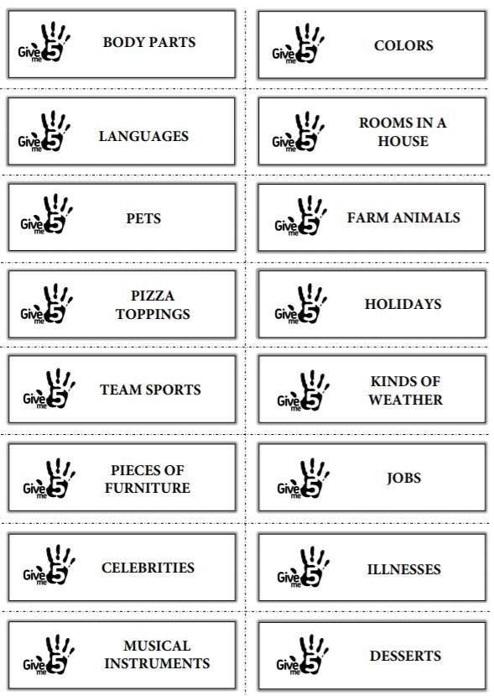
COLOURS

COLOURS

Poetry – ‘Hand on the bridge’ by Michael Rosen

Click on link to be taken to the video of the story: https://www.youtube.com/watch?v=lXz1W7jxwKY

- Listen to / Read the poem (the words are below)
- Learn it
- Perform it
- Record it, if you can, so you can watch your performance back. Then upload to Tapestry so your teachers can hear/see your performance too.

Hand on the bridge.
Hand on the bridge feel the rhythm of the train,
Hand on the window feel the rhythm of the rain.

Hand on your throat, feel the rhythm of your talk, Hand on your leg, feel the rhythm of your walk, Hand on the sea, feel the rhythm of the tide, Hand on your heart, feel the rhythm inside, Hand on the rhythm, feel the rhythm of the rhyme, Hand on your life, feel the rhythm of time,
Hand on your life, feel the rhythm of time, Hand on your life, feel the rhythm of time.

- See what other Michael Rosen poems you can find, learn and recite.

Get musical
- Use items from your recycling bin to make musical instruments.
- Make sure the items are clean and safe before you use them.
- Once they are made, create a piece of music or play along to your favourite songs.
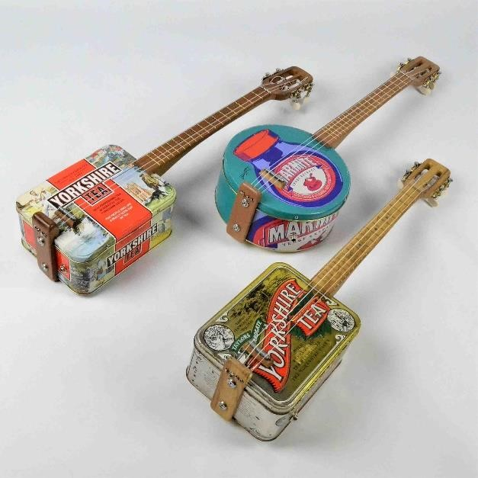
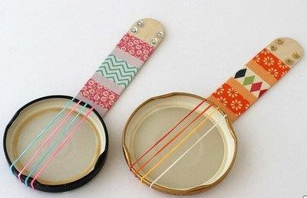
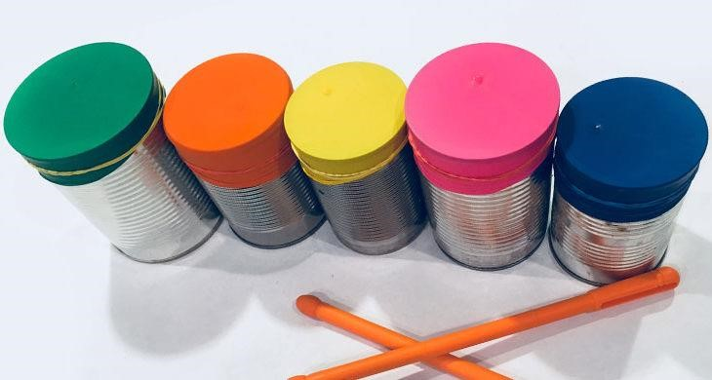
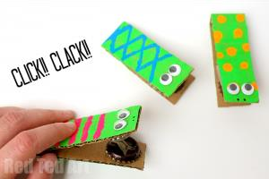
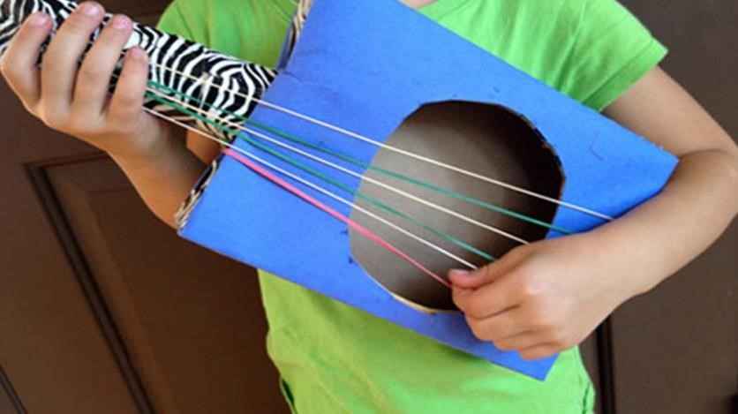
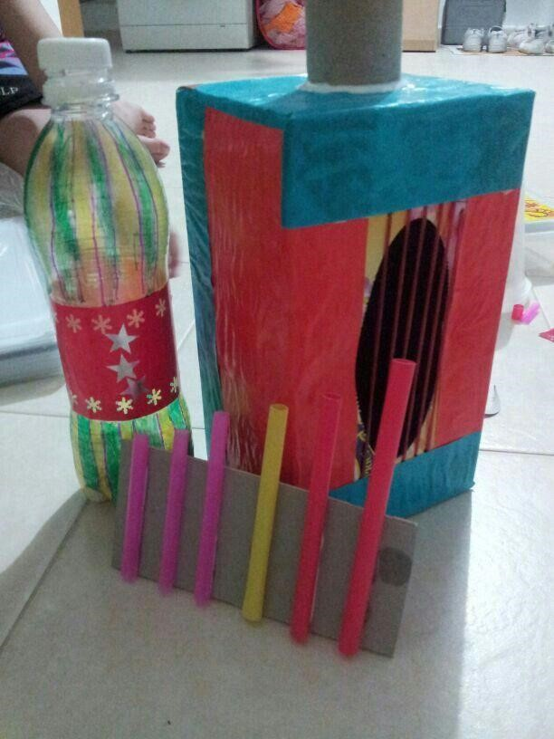

Make a rainbow
- Find one item of each colour of the rainbow, for a chosen category.
- How many categories can you complete?
- Choose your own category for the last row

 | red | orange | yellow | green | blue | purple | pink
clothes
food
items
made from
paper or card
flowers
toys
items
made from plastic
sweets
Number hunt
- Find one item from each category (e.g. for the category ‘packet’ you may pick up a packet of crisps).
- Look at the item and see whether it has any numbers on it. Tick the numbers off on the grid.
- Choose your own category for the last row.

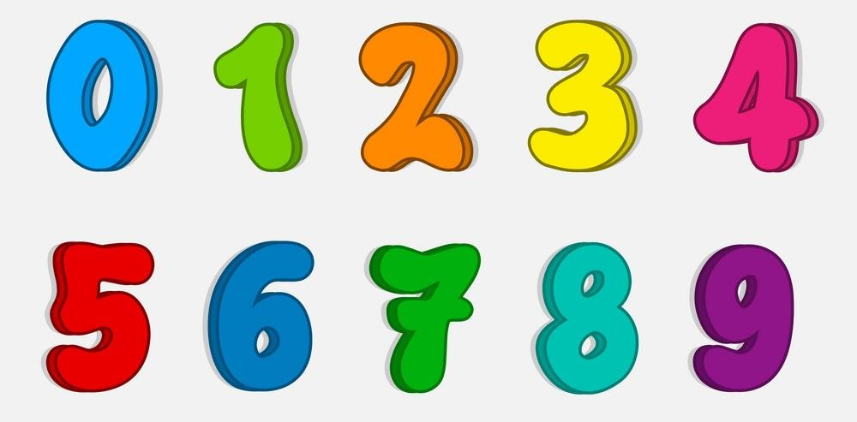

 | 1 | 2 | 3 | 4 | 5 | 6 | 7 | 8 | 9
packet
letter
junk mail
box
tin / can
car registration plate
advert

Say “Cheese”!
- Draw a family portrait

