Maths  Learning Focus: I can solve problems involving doubling and halving. (You could use objects to help.)  On Wednesday, Mrs Rowlands will upload a Maths lesson onto Tapestry focusing on doubling and halving.  Examples of doubling and halving number problems: I have 10 cakes; I put half on a plate for my family to eat and the other half away in a box. How many cakes should I put on the plate?  Normally I have 2 sausages for my dinner but today Mum has said that I can have double the number of sausages. How many sausages will I have in total today?  Doodle maths We have had such wonderfully positive feedback from most Reception parents about doodle maths. So if you have not signed up yet, please do! Let us know if you need help. | Year Reception  Home Learning Week 9  Week Beginning: 18/05/20  Here are some suggested home learning ideas for the week. We understand in these challenging times that all of these activities may not be able to be completed. Please enjoy doing what you can.  smos9315@blake.oxon.sch.uk  nrowlands@blake.oxon.sch.uk  soconnor@blake.oxon.sch.uk | English  Learning Focus: I can practise forming my letters correctly.  Here are some helpful tips, documents and links for correct letter formation:  - Try to sit your letters on the line and keep your letters a similar size. Look out for ascenders (the parts of letters that are taller) and descenders  (the parts of letters that go below the line).  - See pages 2 of this document for the family groups of letters (i.e. the letters that are formed in similar ways).  - See page 3 of this document for the phrases that we use for forming each letter.  - We will post a handwriting video on Tapestry for your children to follow.  - Printable handwriting sheets on Twinkl: https://www.twinkl.co.uk/resource/t-l-5815-letter-families-and-cvc-words-handwriting-activity-sheet-pack
Topic
Learning focus: I can learn about the Muslim practice of Ramadan and celebration of Eid.

Here is a powerpoint about Ramadan and Eid: https://www.twinkl.co.uk/resource/t-t-2547163-eyfs-all-about-ramadan-powerpoint
Here is a lovely ebook link: https://www.twinkl.co.uk/resource/rameenas-ramadan-ebook-t-or-1353
Follow up questions from the ebook:
- How did Rameena and her family celebrate Ramadan and Eid?
- How do you and your family celebrate special occasions? (e.g. Christmas)
Phonics/ Spelling  This week’s uploaded videos for Phonics will be as follows:  - Mrs King’s and Mrs Noel’s groups will be learning ‘ow’ on Tuesday and ‘oi’ on Thursday.  - Mrs Rowlands’s group will be learning ‘ie’ on Tuesday and ‘ea’ on Thursday.  - Mrs Moss’s group will be learning the split digraph ‘u-e’ on Tuesday and ‘kn’ on Thursday.  Your child could also learn how to spell set 10 of their sight words.  Useful links:  Starfall: https://www.starfall.com/h/ltr-classic/ |  | Reading  Try to make sure you are doing a little bit of reading every day.  Have a look on the Oxford Owl website. They have lots of free online books: https://www.oxfordowl.co.uk/  Take a look at Audible. They have lots of free audio books to listen to: https://stories.audible.com/start-listen
P.E.
This week you may like to login to the following website. It has a collection of great videos and ideas for keeping fit and moving.
The website address: home.jasmineactive.com
Parent email: parent@blakecofep-1.com
Password: blakecofep
When your children come back to school, they will be able to share their home learning book and any special pieces of work they have completed with their class teacher.
Families of Letters
These are the family groups of letters. This is how we form each letter.
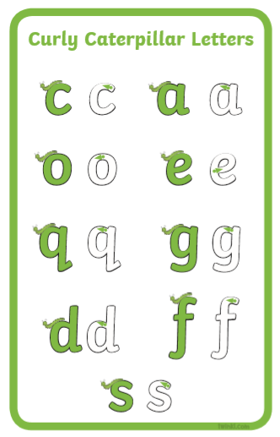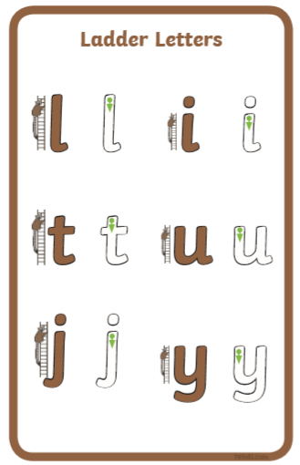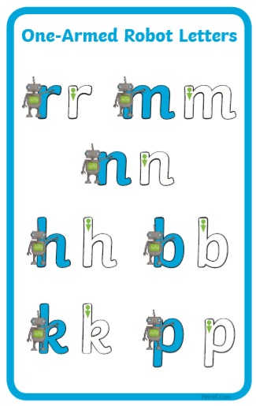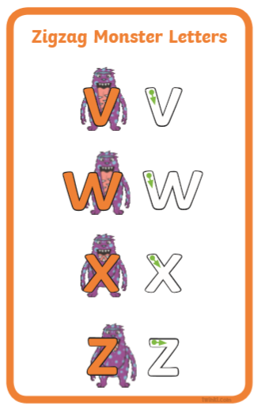

Handwriting Phrases
Below are the phrases we use in order to help the children form their letters correctly. We have grouped them into the families of letters.

Curly Caterpillar Letters
a Round the apple, down the leaf.
g Round her face, down her hair and give her a curl.
o All around the orange.
c Curl around the caterpillar.
s Slither down the snake.
d Round his bottom, up his tall neck, down to his feet (dinosaur).
f Down the stem and draw the leaves.
e Lift off the top and scoop out the egg.

Ladder Letters
t Down the tower, across the tower.
i Down the body, dot for the head.
l Down the long leg.
y Down a horn up a horn and under his head (yak).
j Down his body, curl and dot (jack in the box).

One-Armed Robot Letters
m Maisie, mountain, mountain.
n Down Nobby, over his net.
p Down the plait and over the pirate’s face.

Zigzag Monster Letters
v Down a wing, up a wing (bird).
w Down, up, down, up.
z Zig-zag-zig.
x x-x-x-exercise. Down the arm and leg and repeat the other side.
u Down and under, up to the top and draw the puddle.
b Down the laces to the heel, round the toe.
k Down the kangaroo’s body, tail and leg.
h Down the head to the hooves and over his back (horse).
r Down his back, then curl over his arm (robot).

